# Frequent Pattern Mining

## Maximum Frequent Itemset[1]

An itemset is MFI if none of its supersets are frequent itemsets. In figure 1, **ad** and **abc** are MFI, because none of their supersets are frequent itemsets.

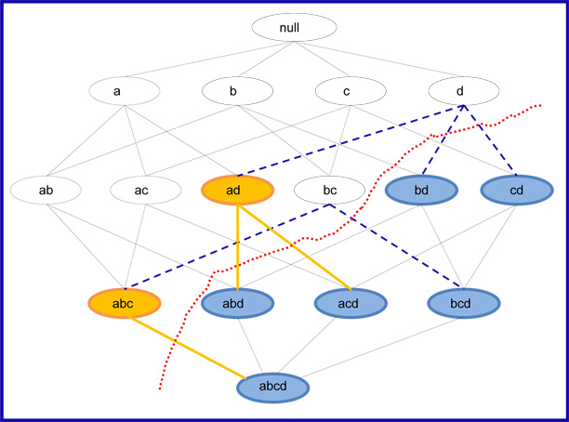

Figure 1

## Closed Frequent Itemset[2]

A closed frequent itemset is where all of an itemset’s supersets has a frequency that are lower than the frequency of the current itemset. In figure 2 itemset **a**, **c**, **cd** and **abd** are CFI (Closed Frequent Itemsets).

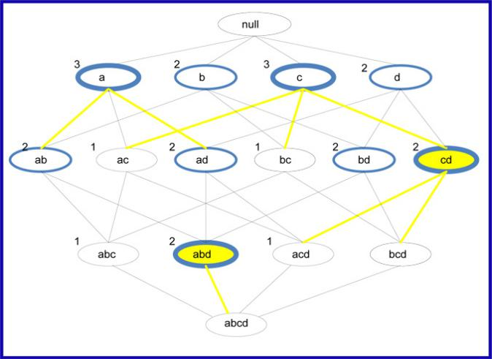

Figure 2

## Apriori

Threshold:

2

|  |  |
| --- | --- |
| 1 | B E |
| 2 | A B C E |
| 3 | B C D |
| 4 | A C E |
| 5 | D E |

Items:

A

B

C

D

E

### C1

|  |  |
| --- | --- |
| A | 2 |
| B | 3 |
| C | 3 |
| D | 2 |
| E | 4 |

### C2

|  |  |
| --- | --- |
| AB | 1 |
| AC | 2 |
| AE | 2 |
| BC | 2 |
| BD | 1 |
| BE | 2 |
| DC | 1 |
| DE | 1 |

### C3

|  |  |
| --- | --- |
| ABC | 1 |
| ABE | 1 |
| ACE | 2 |
| BCD | 1 |

### C4

|  |  |
| --- | --- |
| ABCE | 1 |

1. <http://www.hypertextbookshop.com/dataminingbook/public_version/contents/chapters/chapter002/section004/blue/page001.html>
2. <http://www.hypertextbookshop.com/dataminingbook/public_version/contents/chapters/chapter002/section004/blue/page002.html>